Weathering vs. Erosion, Soil vs. Dirt, and the Rock Cycle
Observations and Description Lab

Learning Objectives:
- Increase observing and recording skills
- Gain knowledge and experience with sediments and soils
- Gain experience characterizing sediments and soils

______________________
Name
______________________
Course/Section #
Weathering vs. Erosion AND Soils vs. Dirt
Observation and Description

Introduction – This experience is aimed at broadening your understanding of weathering, erosion, sediments, and soils as they pertain to the rock cycle and your daily lives. Since every environment on earth is developed by specific biogeochemical parameters the pattern of sediments left behind will also be unique. (Hint – You should view sediment patterns and soils as ‘fingerprints’ to the conditions in which there were developed; Even if those environmental conditions have since changed!).

Instructions – This laboratory is divided up into eleven stations. Proceed through this lab at your own speed and in any order you choose. You should try to complete as many stations as possible during the lab, with a minimum of six.

Stations
Station 1: Environments of Deposition
Station 2: Sediment texture
Station 3: Sediment properties
Station 4: Minerals, rocks, and parent materials
Station 5: Soil texture
Station 6: Soil color
Station 7: Soil structure
Station 8: Soil diversity
Station 9: Soil/weathering horizons
Station 10: Soil surveys
Station 11: Landscape stability and paleosols

Please comment on the following questions prior to starting the lab.

Compare and contrast
1. Weathering & Erosion

2. Soil & Dirt

3. I currently think there are _____________ types of different soils.

4. How do soils relate to your daily life?

5. Where/How do sediments and soils fit into the rock cycle?

Station 1: Environments of Deposition (@ the Stream table)

Environments of deposition are natural areas possessing specific combinations of physical, chemical and biological processes that lead to unique sediment arrangements. For example, the sediment on a beach will be different from the sediment that you may find on a flood plain.

Sediments = Solid fragmented material, such as silt, sand, gravel, chemical precipitates, and fossil fragments, that is transported and deposited by water, ice, or wind or that accumulates through chemical precipitation or secretion by organisms, and that forms layers on the Earth's surface. Sedimentary rocks consist of consolidated sediment.

Describe at least two different environments of deposition within the stream table. (Topics you should think about including in your sediment descriptions are – color, size, sorting, thickness, rounding or angularity, etc.)

Station 2: Sediment particle-size

One of the ways geologists characterize environments of deposition is by measuring the size and distribution/pattern of sediments that occur on the Earth. One tool for measuring sediment particle-size is a sieve set…

Sediment Grain Sizes
Millimeters | Wentworth Grade | Phi (Φ) Scale
>256 | Boulder | –8
>64 | Cobble | –6
>4 | Pebble | –2
>2 | Granule | –1
>1 | Very coarse sand | 0
>1/2 | Coarse sand | 1
>1/4 | Medium sand | 2
>1/8 | Fine sand | 3
>1/16 | Very fine sand | 4
>1/32 | Coarse silt | 5
>1/64 | Medium silt | 6
>1/128 | Fine silt | 7
>1/256 | Very fine silt | 8
<1/256 | Clay | >8

Use the provided sediments (A and B) and the sieve set to answer the following questions
1. List the size distribution for sediment Group A and B
Group A =

Group B =

2. Which sediment group to you think took more energy to transport? Justify your response

Station 3: Sediment properties (binocular microscopes on the side tables)

Sediments A, B, and C have been collected from different rivers. Using the microscope if you wish, compare these sediments. Examine their degree of sorting, i.e., are the sand grains in a specific tray all about the same size (well sorted) or is there a wide range of sizes present (poorly sorted). Also examine the degree of roundness of the sand grains and their compositions (mineralogy). How do these characteristics relate to the length of time and the distance over which the sand grains have been transported?

Station 4: Minerals, rocks, and parent materials

Write a proper definition for a mineral –

Write a proper definition for a rock –

Parent material is the underlying geological material (generally bedrock or surface sediments). Using the three samples provided (A, B, and C) describe the characteristics of the soils that would likely develop from each sample. How would these soils be different, why? Which of these soils would likely be the most agriculturally productive, why?

Station 5: Soil texture

Soil texture is related to sediment particle-size. Soils by definition consist of particles that are smaller than 2mm.

Name of soil separate Diameter limits (mm) (USDA classification)
Clay less than 0.002
Silt 0.002–0.05
Very fine sand 0.05–0.10
Fine sand 0.10–0.25
Medium sand 0.25–0.50
Coarse sand 0.50–1.00
Very coarse sand 1.00–2.00

Use the chart to characterize the amount of sand, silt, and clay in the sample group A and B. How does A compare to B?

Station 6: Soil color

Soil scientists use the Munsell color guide to characterize, you guessed it, soil color. Color is one property of soil that can also tell you a lot about environmental conditions that developed that soil.

Use the Munsell Color Guide to id the color of each soil sample (A, B, and C)
** PLEASE do not touch the color chips in the guide, hold the corner of the page with on hand and hold the sample behind the page with your other hand until you find a suitable match.

Sample A =

Sample B =

Sample C =

Station 7: Soil structure

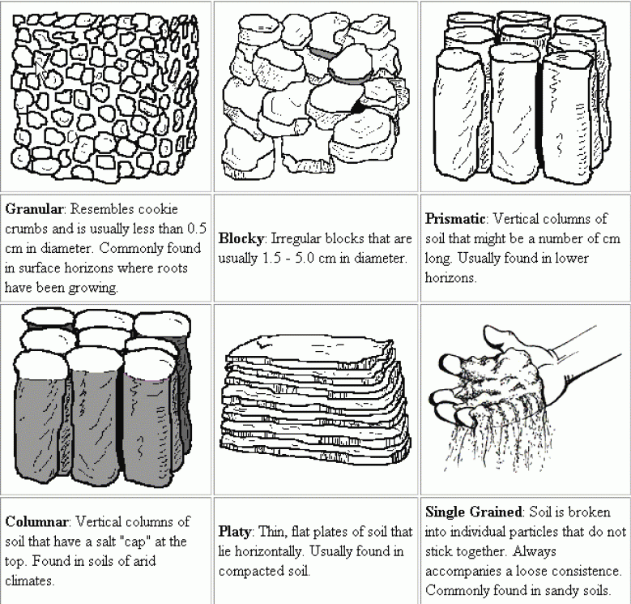

Using the chart above what type of soil structure is present in samples A and B?

Sample A =

Sample B =

Station 8: Soil diversity

Read and discuss the provided materials then write a paragraph about the diversity (Types) of soils.

Station 9: Soil/weathering horizons
Using this link -
http://higheredbcs.wiley.com/legacy/college/strahler/0471417416/animations/ch10/animation1.htm

Draw a soil profile to the left and to the right (write a short discussion of each horizon that defines its formation and subsequent indentifying properties).

Station 10: Soil surveys
A soil survey is a detailed report on the soils of an area. The soil survey has maps with soil boundaries and photos, descriptions, and tables of soil properties and features. Soil surveys are used by farmers, real estate agents, land use planners, engineers and others who desire information about the soil resource
Use the Black Hawk County Soil Survey to answer the following questions…

1. Compare and contrast the Chelsea Series/Horizons versus the Floyd Series/Horizons…

2. Identify 3 soil types that would be good for Hardwood trees, wetland wildlife, playgrounds
Identify 3 soil types that would be very poor for Hardwood tree, wetland wildlife, playgrounds.

3. If you had $300,000 to build a house what pattern of soils and parent material association would you choose? E.g. Tama-Muscatine-Garwin OR Dinsdale-Klinger-Maxfield, etc.

Station 11: Landscape stability and paleosols

Using the materials provided, do think soils develop on stable or unstable surfaces? How do weathering and erosion relate to the stability of a landscape? What are paleosols and why are they useful?

Please comment on the following questions prior again…

Compare and contrast
1. Weathering & Erosion

2. Soil & Dirt

3. I currently think there are _____________ types of different soils.

4. How do soils relate to your daily life?

5. Where/How do sediments and soils fit into the rock cycle?

